CURRICULUM VITAE  ANARA BATYRKHANOVA |  |  |  |  |  |  |  |  | 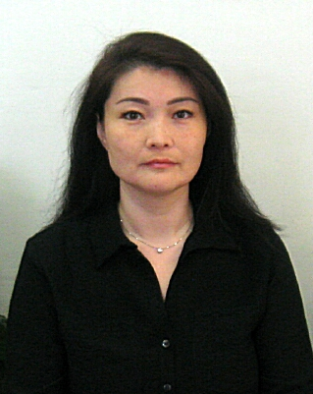
Date of birth: |  | July 25, 1982 |  |  |  | Tab. №: |  |  |  | 20
Place of birth: |  | East-Kazakhstan Region, Ust-Kamenogorsk
Nationality: |  | Kazakh |  |  |  | Education: |  |  |  | Higher
Name of educational instituition: |  |  |  | Qualification: |  | Year of Graduation |  |  |  | Program
East-Kazakhstan State Technical University n.a. D. Serikbaev |  |  |  | economy (by industry) |  | 2004 |  |  |  | Full-time
Marital status, children: |  |  | Residential address (actual): |  |  | Contact details:
Married, son 2013 y.b., doughter 2009 y.b. |  |  | Ust-Kamenogorsk,  2, Ust-Kamenogorskaya str., 15
Language proficiency: |  |  |  |  | Military service:
Kazakh, Russian, English |  |  |  |  | no
Awards, certificates, orders: |  |  | Disciplinary penalties: |  | Work completion contract: |  |  | Participation in competitions:
- |  |  | -
Training: |  | Course "Training for internal audit", Grand Tornthon LLP, 2019. (Certificate), Terralink Technologies LLP. Courses on implementation of the SAP module, 2020 (Certificate)
Absence cover: |  | -
Maternity leave |  | -
Recommendation: |  | -
WORK EXPERIENCE
Date |  | Position, name of the company |  |  |  |  | Location
Recruitment | Transfer/  Dismissal
08.2005 | 02.2006 | Air separation unit operator | Shop №7 | UKTMP JSC |  |  |  |  | Ust-Kamenogorsk
02.2006 | 06.2008 | Secretary-typist | Shop №7 | UKTMP JSC |  |  |  |  | Ust-Kamenogorsk
06.2008 | 12.2010 | Production Cost Planning Specialist, Economic and Investment Planning Department | ED | UKTMP JSC |  |  |  |  | Ust-Kamenogorsk
12.2010 | 06.2011 | Specialist | Procurement Departgment | UKTMP JSC |  |  |  |  | Ust-Kamenogorsk
07.2011 | 10.2014 | Production Cost Planning Specialist, Economic and Investment Planning Department | ED | UKTMP JSC |  |  |  |  | Ust-Kamenogorsk
10.2014 | 05.2015 | Acting Head of the Office | Office | UKTMP JSC |  |  |  |  | Ust-Kamenogorsk
05.2015 | 09.2019 | Accountant of the department of accounting of fixed assets, materials and capital costs | Accountand Department | UKTMP JSC |  |  |  |  | Ust-Kamenogorsk
09.2019 | 01.2022 | SAP support department specialist for Automation And Information Technology Development Department| UKTMP JSC |  |  |  |  | Ust-Kamenogorsk
01.2022 | 09.2022 | Leading Specialist | Support Department of Automation and Information Technology Development Department | UKTMP JSC |  |  |  |  | Ust-Kamenogorsk
09.2022 | 01.2024 | Acting Head | SAP Support Department of Automation and Information Technology Development Department | UKTMP JSC |  |  |  |  | Ust-Kamenogorsk
02.2024 | Up to now | Head | SAP Support Department of Automation and Information Technology Development Department | UKTMP JSC |  |  |  |  | Ust-Kamenogorsk

